- Bolt the flywheel to the LS Engine Block using a ¾” 12-point socket and 6 ARP flywheel bolts if purchased with the kit. If you did not purchase the ARP bolts follow the torque spec of the bolts you will be using. Add RTV silicone sealant to the flywheel bolts to prevent any oil from leaking out from the crankcase. Tighten the bolts by hand until they are snug, then tighten each of them to 15ft-lbs in a crisscross pattern. Follow this by 36ft-lbs and finally 74ft-lbs, continuing the crisscross pattern.
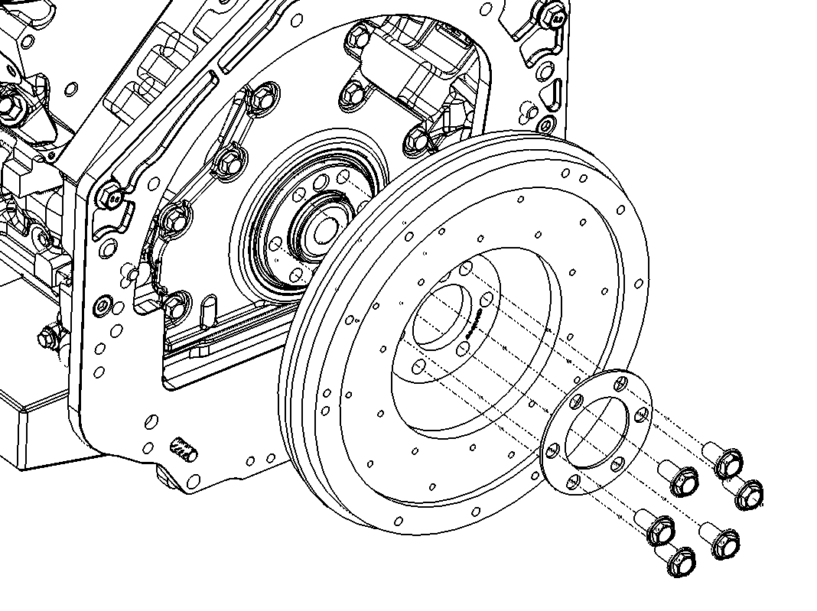

- Clean the flywheel surface from any oil residues by spraying it with brake clean (or similar cleaning spray) and wiping it down with a cloth.

- Install your clutch disc and pressure plate. Be sure to add Loctite to the pressure plate bolts and install these bolts in a similar crisscross pattern as the flywheel bolts. Use a torque wrench to tighten these bolts starting at 7 ft-lbs., then 18 ft-lbs., then 32 ft-lbs. following the crisscross pattern. (Any single clutch disc and pressure plate originally designed for use on a 350z or 370z will work)

